The Fingerpad

**Introduction**

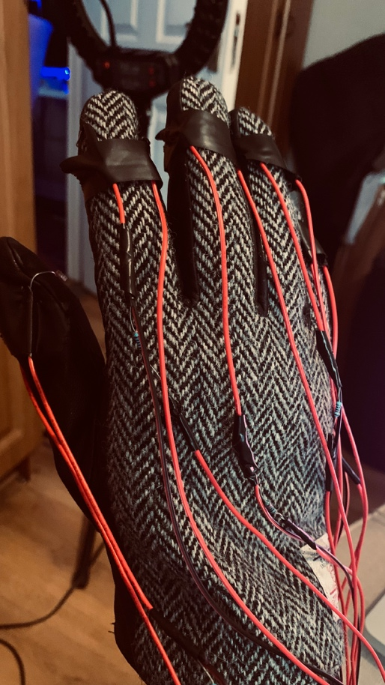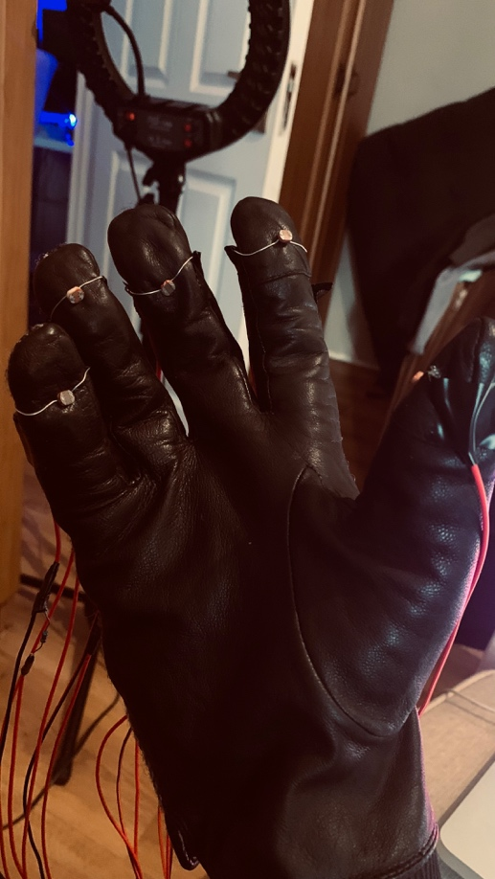

This device (Figerpad Glove) investigates the interaction between humans and hardware in a musical context. The device is given the name Fingerpad so that’s how it will be named in this writeup throughout.

An ordinary glove is transformed into an interactive instrument for this project. On each fingertip of the gloves, including the thumb, LDR sensors are affixed so that Arduino and Supercollider can be used to transform the gloves into an instrument. The index finger is assigned a frequency of 440 hertz, the middle finger is assigned a frequency of 600 hertz, the ring finger is assigned a frequency of 720 hertz, and the little finger is assigned a frequency of 990 hertz. The amount of light determines the amplitude of these frequencies, and the intensity of the light on the thumb affects the pitch of the frequencies assigned to each fingertip.

**Circuit of Arduino:**

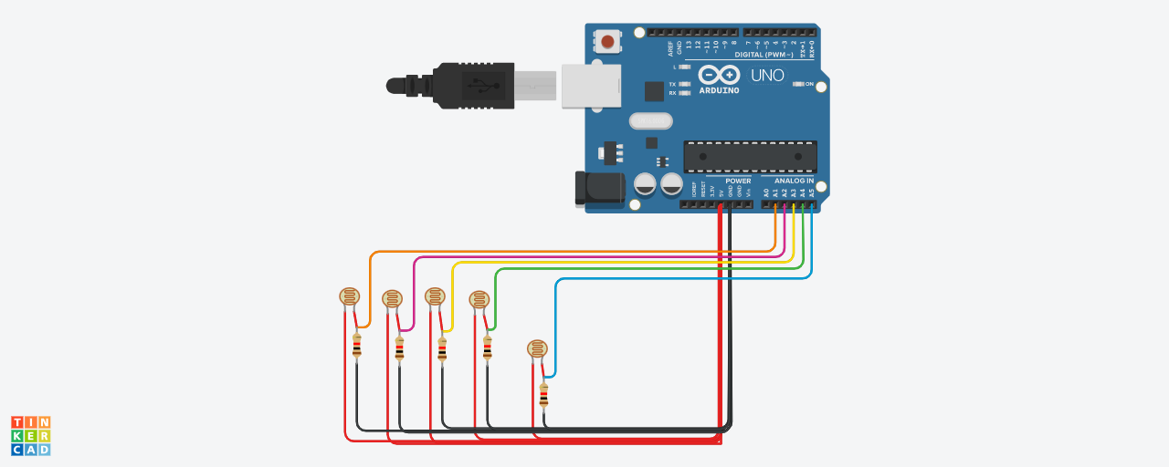

LDR and 10k Ohm resistor are connected in series and the Arduino is reading the voltage at the junction between the LDR and the resistor. The resistance of the LDR is directly proportional to the amount or intensity of light striking the LDR, which alters the voltage across the junction. With an increase in light intensity, the LDR's resistance decreases and the voltage at the junction rises. The Arduino converts this voltage, which ranges from 0 to 5 volts, into a digital reading between 0 and 1023.

**The code running inside the Arduino is :**

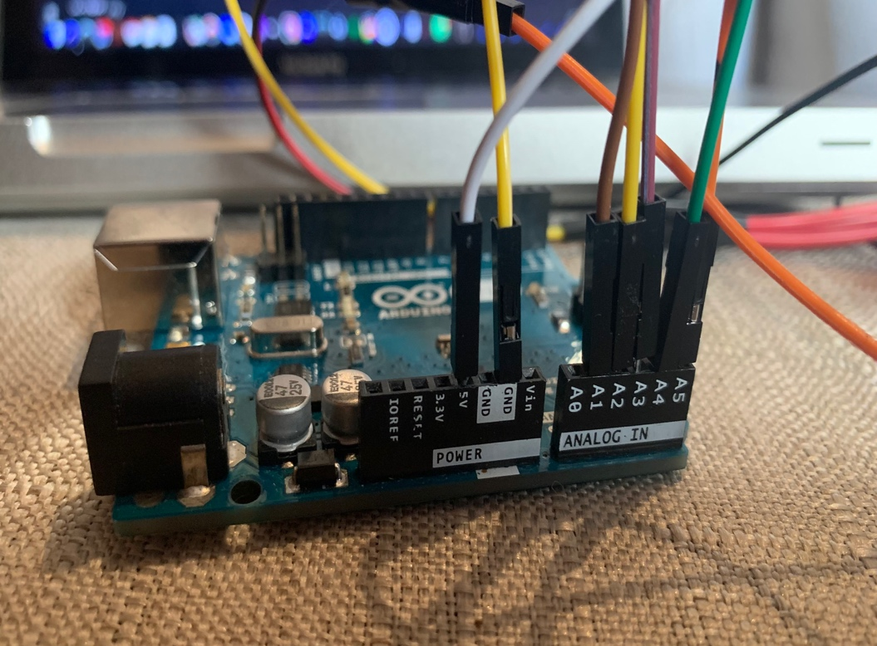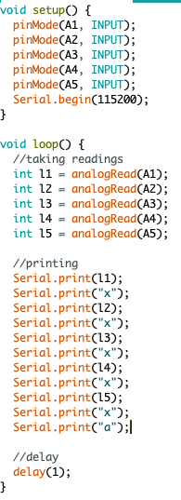

This function runs for once to setup the ports for the Arduino.

A1, A2, A3, A4, A5 are the analog pins (analog pins are used when the inputs are in a range) which are used for taking inputs from LDRS.

The readings are printed in a certain format (ldr1xldr2xldr3xldr4xldr5xa) on the serial monitor which are read by the supercollider.

After completing the preceding steps with Arduino, the subsequent steps are carried out with Supercollider.

**Work of Supercollider:**

After the processes above the through Arduino, following results had to be accomplished using the Supercollider

1. 4 different sine wave frequencies have been programmed into different fingers’ LDR. Pitch of those sine wave is manipulated by thumb LDR.
2. The intensity of light on the LDR is used as a reading to determine the amplitude for synth of the finger. So, the amplitude of each finger depends on the intensity of light of surrounding.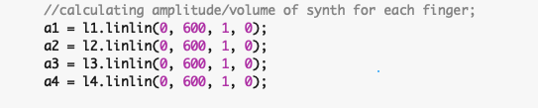

Brief explanation of what was done in the code above:

For example, the first finger, the reading by the LDR is saved in variable 1, and a threshold of 600 is used to convert the intensity range of 0 to 600 into an amplitude range of 1 to 0. As the intensity decreases from 600 to 0, the amplitude increases from 0 to 1.

1. The manipulation of pitch of each finger is being controlled by the LDR on the thumb. In the code below “th” is thumb.

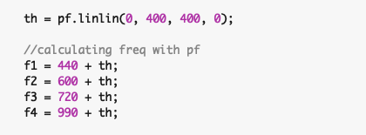

1. In order for the Thumb LDR to function, certain conditions must be met. Four-finger pitch is impacted if the thumb LDR reading surpasses the threshold light intensity reading of 400, as previously mentioned.
2. If the condition above is not met then the synth on each finger will play a same note without any change in its pitch throughout.

For example,

If finger 1 (the index) is playing 440 hertz and the intensity of the thumb reading goes below 400 and it reads 300 unit then the increase in pitch would be the difference ie 100 hertz. So the resulting frequency would be 540 hertz. This should be kept in mind while using this instrument. 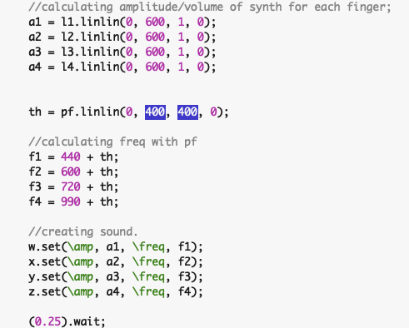

The supercollider read the input from the serial monitor character by character. A sequence of digits terminated by character “x” is combined to form one reading of LDR, such five consecutive sequences of digit gives reading of 5 LDR terminated by the character “a”. These readings are saved in their respective variables in a loop.

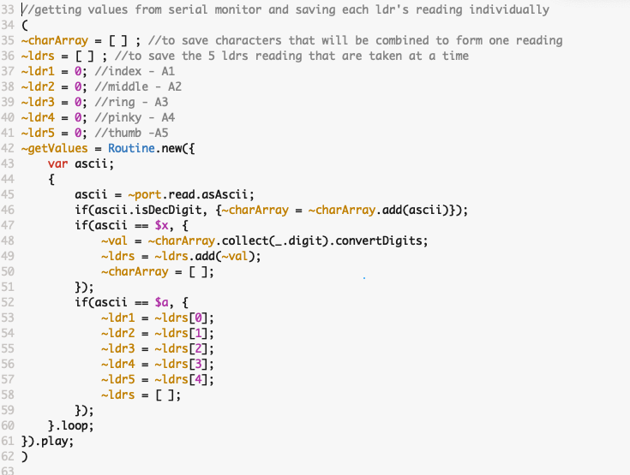

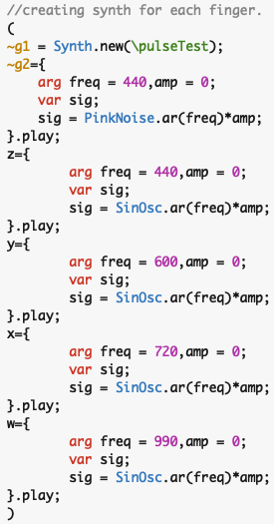

Here we are creating 6 different synth; 2 for gestures and 4 for the fingers, the frequency and the amplitude of the synth for the fingers can be manipulated by this.

The readings are printed in a certain format (ldr1xldr2xldr3xldr4xldr5xa) on the serial monitor which are read by the supercollider.

**Arduino Part:**

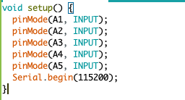

**The code above is used to designate the pin.**

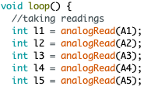

**Then the above code is used to take the readings.**

**The connection of Arduino with supercollider.**

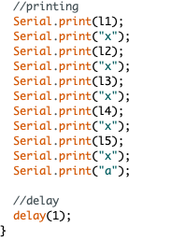

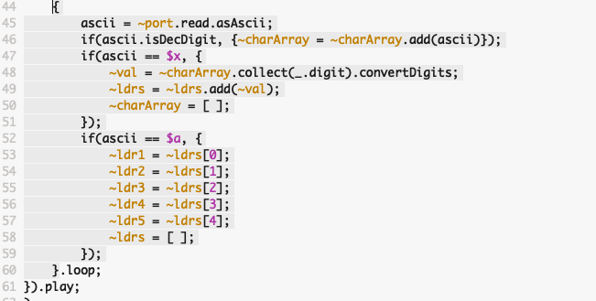After each LDR reading the character ‘x’ is used to know the break and ‘a’ is used to know when the 5 LDR readings has been taken. The Arduino is used to print the readings in the required format, and the super collider reads it and gets the individual reading of each LDR.

**GESTURE 1 SynthDef**

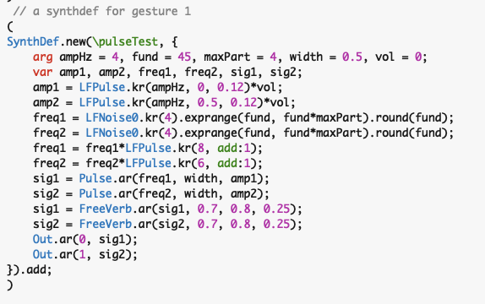

**SynthDef for this gesture is derived from a YouTube Video with minor modifications**

# **SuperCollider Tutorial: 3. Synth and SynthDef by Eli Fieldsteel**

**Gesture 2 (The one with the Simple Pink Noise)**

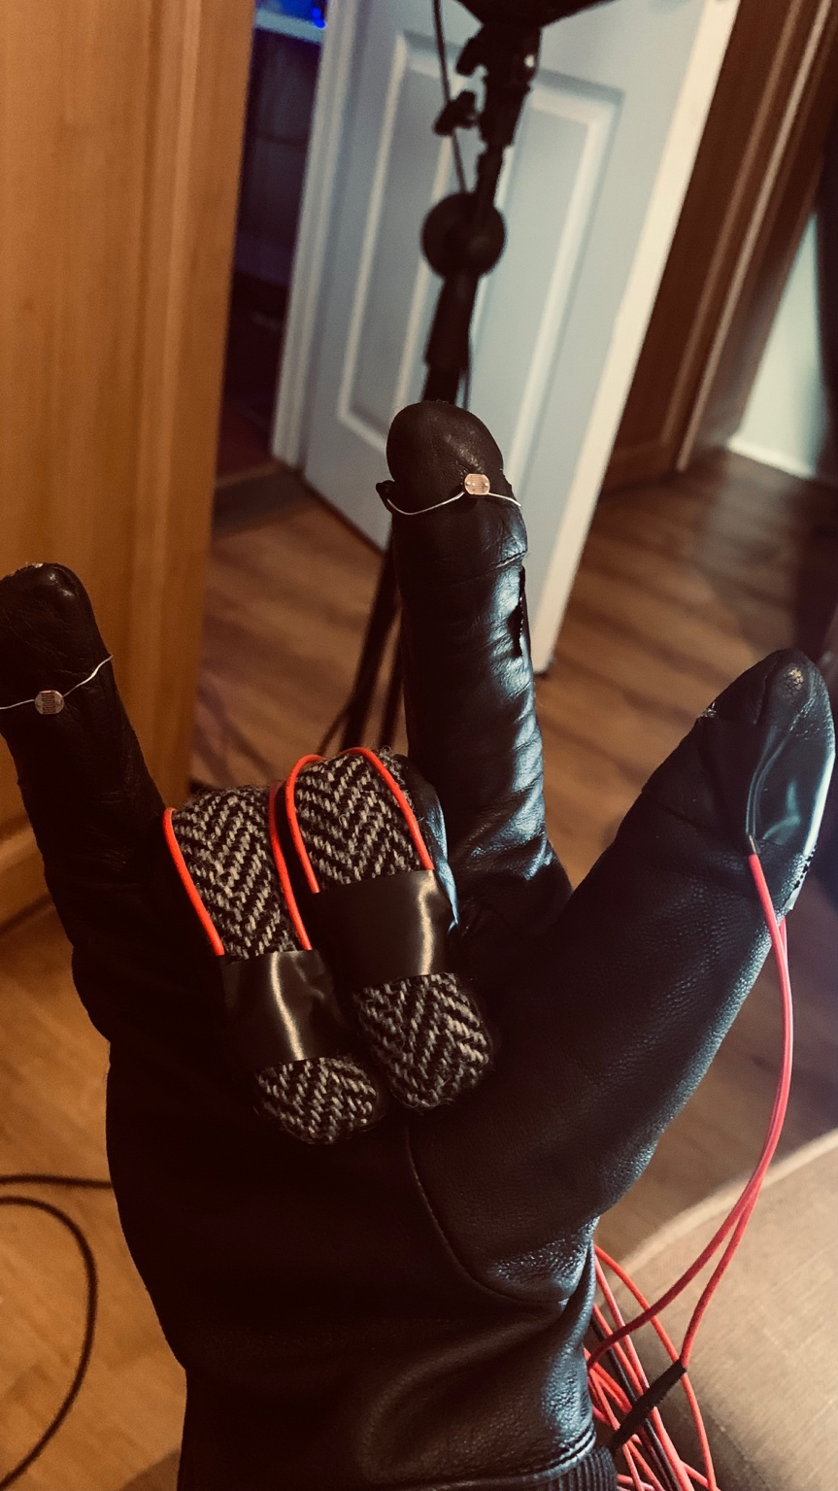

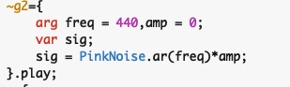

**Working of gestures**

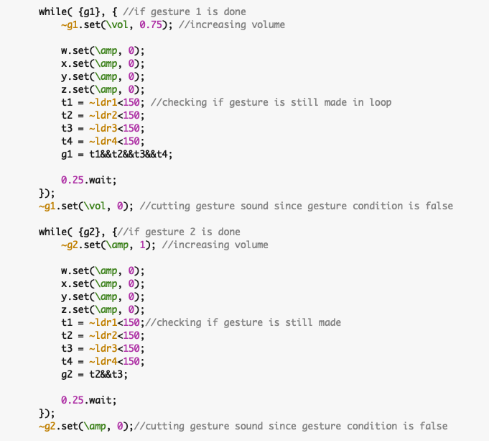

**If any of the gesture's conditions are met, the respective gesture's sound is generated and the checking of the gesture's condition is repeated; if the gesture's condition fails, the sound is terminated.**